FEASIBILITY OF PUC ANALYZER FOR EXHAUST GAS ANALYSIS

Akshay Srivastava (Department of Chemical Engineering, Manipal University Jaipur)

INTRODUCTION TO THE PUC ANALYZER

The PUC gas analyser is an **infrared gas analyser** that measures the trace gases by determining the [absorption](https://en.m.wikipedia.org/wiki/Absorption_(electromagnetic_radiation)) of an emitted [infrared](https://en.m.wikipedia.org/wiki/Infrared) light source through a certain [air](https://en.m.wikipedia.org/wiki/Air) sample. Trace gases found in the Earth's atmosphere get excited under specific [wavelengths](https://en.m.wikipedia.org/wiki/Wavelengths) found in the infrared range. The concept behind the technology can be understood as testing how much of the light is absorbed by the air. Different molecules in the air absorb different frequencies of light. Air with lots of a certain gas will absorb more of a certain frequency, allowing the sensor to report a high concentration of the corresponding molecule. The device functions on the principle of IR spectroscopy (which has been discussed briefly below) and since the detection of the gas is characteristic, the problem of cross detection of different species is nullified.

WORKING PRINCIPLE OF THE PUC ANALYZER

The PUC gas analyser works on the principle of **IR spectroscopy**. This method of chemical detection relies on the basic fact that **different chemical species have characteristic absorption spectra for IR radiation** (due to the presence of different bond orientation, lengths and strengths between the constituting atoms). Upon the blasting of IR radiation, the molecule absorbs the incident radiation and starts to vibrate (due to the external energy imparted to it) and hence only the frequency of the **unabsorbed radiation** passes through and is recorded as the characteristic spectra.

For analysis in a state of the art IR gas analyser, the spectrum of the sample is compared against a reference sample (to eliminate the background absorption and hence external noise). The reference gas in case of a PUC analyser contains clean air (air that contains impurities well under the government defined guidelines). This method of analysis is the most common one in the case of pollution control analysis and is known as the dual beam analysis (alternative mode being single being analysis where reference analysis data is pre-fed into the machine as opposed to simultaneous analysis).

SPECIFICATION OF PUC ANALYZER

The specifications of a government approved PUC device is as follows:

Species to be detected:

* Carbon monoxide (CO)
* Carbon dioxide (CO2)
* Hydrocarbons (HC, in terms of n-hexane)
* Oxygen (O2) at the moisture level.

Description of the device: Generally, the instruments shall provide a means for sampling and then measuring the exhaust gases emitted from the tail pipe of a motor vehicle. A pump shall be provided to transport the gas sample through a gas sample handling system. One or more detection devices may be used and incorporated in the gas handling system to analyse the sample and provide signals related to the volumeume fractions of gas components of interest, namely CO, CO2, HC and O2. The detector signals are then electrically processed to display and record the results of a measurement in volumeumetric units of the gas components together with other important related information such as a lambda value calculation.

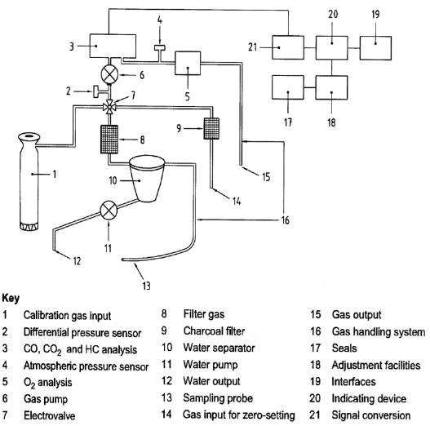

The major instrument components in a PUC analyser are as follows:

* a sampling probe introduced in the tail pipe of an operating motor vehicle to

collect the exhaust gas sample

* a hose with associated tubing connected to the probe to provide a path for the gas sample to enter, pass through and exit the Instrument
* a pump to convey the gases through the Instrument
* a water separator to prevent water condensation from forming in the Instrument
* a filter to remove particulate matter that could cause contamination of various sensitive parts of the Instrument
* Ports downstream from the water separator and filter to introduce ambient air and calibration gas when required by the technology used. The calibration gas port should have a suitable provision for connection to the pressurized 10 / 47 litre gas cylinders by the means of ¼” Teflon tube and compression tube fitting.
* Detection devices to analyse the gas sample into its components according to volumeume fractions
* a data system to process the signal and an indicating device to display the results of a measurement and
* a control facility to initiate and check Instrument operations and a manual, semi-automatic, or automatic adjustment facility to set Instrument operating parameters within prescribed limits.
* Either a built-in printer and/or an RS 232 serial interface through which the data can be transferred to a PC.

The measuring ranges for a market standard PUC machine are within the following. It should be noted that the volume fractions of the gas components shall be expressed as a percentage (% volume) for CO, CO2 and O2 and in parts per million (ppm volume) for HC. The permanent inscriptions for these units or electronic display shall be assigned unambiguously to the indication, for example “% volume CO”, “% volume CO2”, “% volume O2” and “ppm volume HC”

**Measuring range:** The minimum indicating ranges shall be as**:**

Minimum resolutions:

CO: 0.01 %volume

CO2: 0.1 %volume

HC: 1 ppm volume

O2: 0.02 %volume

The accuracy of these measurements is affected by the following factors (the following also include the reference conditions for the measurments):

a) Temperature: 25 °C ± 2 °C

b) Relative Humidity: 60 % ± 10 %

c) Atmospheric Pressure: Stable ambient

d) Mains voltage: ± 2% Nominal voltage ± 1%, Nominal frequency

For accurate measurements, it is recommended to operate the analyser within the following physical conditions:

a) Temperature: 5°C to 45°C

b) Relative Humidity: up to 90 %

c) Atmospheric Pressure: 860 hPa to 1060 hPa

d) Mains voltage variation: – 15 % to + 10 % of the nominal voltage, ±2 % of the nominal frequency.

If a battery is used to power the instrument, the limits of power supplied shall be within the instrument manufacturer’s specifications. In case the battery power drops outside the limits, there should be an indication on the instrument and it should not be possible to make any measurement with the instrument. If a portable generator is used, its requirements shall comply with the specifications for the mains voltage.

To avoid cross-sensitivity, it should be ensured that the following gases do not exceed the given concentrations in the flue gas composition:

16 % volume CO2

6 % volume CO

0.3 % volume NO

5 % volume H2

10 % volume O2

5000 ppm volume HC (as n-hexane)

water vapor up to saturation.

However, the presence of H2 is not necessary for testing the O2 channel and the presence of H2 and O2 is not necessary in case of Infrared technology.

**Response time**

For measuring CO, CO2 and HC, Instrument including the specified gas handling system shall indicate 95 % of the final value (as determined with calibration gases) within 15 s or less after changing from a gas with zero content. For measuring O2 the instruments shall indicate a value differing less than 0.1 % vol. of the final value within 60 s after changing from air to oxygen-free calibration gas.

**Warm-up time**

After the warm-up time, the Instruments shall meet the metrological requirements as stated in this document. Instruments shall have the means to prevent measurement and an indication of measured gas volume fractions during the warm-up time. Instruments shall have a warm-up time not exceeding 10 min.

*In this document, only relevant specifications have been mentioned, whilst other specification such as the lambda factor, the propane/hexane correction factor and shock and electrical resistances for the devices have been omitted. These are mentioned in details in the reference material provided.

CONCLUSION:

Though these analysers may be cheaper that off the shelf sensor (average cost of a PUC analyser ranges from Rs.1—1.5 Lakh) that meet out requirements precisely, these machines would not provide accurate results (far from) as the operating conditions for these analysers do not meet the required criteria. Furthermore, though these machines ensure no cross detections, the ranges in which the said is true is too small and hence it is recommended that industrial sensors are used for this application.